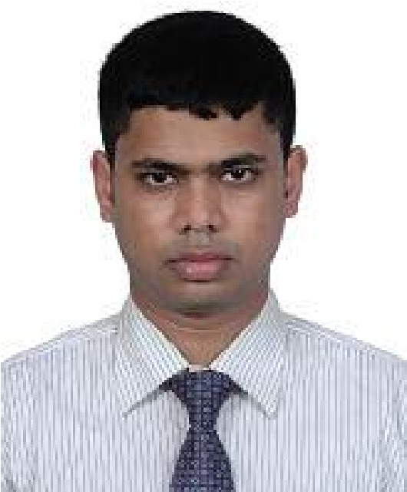Date: 08/10/2020

**SHAMS-E-ADATH**

C/O, Md. Shahadath Hossain

Assure Wisteria, Flat No. A-7, Road No. 1,

Avenue No. 1, Block B, Plot No. 86, Kalshi Main Road,

Mirpur, Sector 12, Dhaka-1216

**Cell:** +8801941684505

**E-mail:** eadath08@gmail.com

**Objective**

A motivated professional working at a renowned oil & gas company in the country are seeking scope to take new challenges where enthusiasm & professionalism can be utilized in a dynamic job environment.

**Job History (Total 5 Years):**

* Working as Senior Executive at Bashundhara Oil & Gas Company Ltd. under **Bashundhara Group** since 02-Feb-2019 upto till today.

**Responsibilities:**

* + Planning, control & maintenance of office transports, office equipment, property assets and other moveable and immovable properties
  + Preparing reports on expenses, office budget and other expenditures.
  + Provide proper support to the operation team so that the process can run smoothly.
  + Ensuring good housekeeping, cleaning & hygiene matter of factory.
  + Prepared a organogram successfully in a professional manner.
  + Generated an overall standard operating procedure (SOP) for HR & Admin department & ensuring about proper implementation.
  + Ensuring proper coordination of administrative support services.
  + Developing & implementing periodical work plans.
  + Managing & arranging uninterrupted logistic support.
  + Create & update records and databases with personnel, financial and other data.
  + Coordinating building & maintenance issues for general repair and updating.
  + Organizing a filing system for important & confidential company documents.
  + Schedule in house & external events.
  + Coordinate with safety & participatory committees.

* Served as a Senior Officer (**Document Controller Cum Project Admin**) at National Development Engineers Ltd. assigned to “***British American Tobacco Company Bangladesh Ltd.***” construction project since 20-Dec-2015 up to 24-Jan-2019.

**Responsibilities**:

* + Working with precision to ensure that all electronic and hardcopy filling is accurate and is easily retrievable.
  + Allocating and controlling the document numbering system for the project work.
  + Support technical projects & departments
  + Planning, coordinate & participating in execution to complete the project works in time
  + Preparing all types of technical / non-technical documents, storing in professional manner & distributing to the appropriate authority.
  + Quality & compliance checking of documents
  + Project reporting on the document status / maintaining KPIs.

**Software & Professional Skills:**

Microsoft Application Package (MS Word, MS Excel, MS Power Point, MS Project), Planning, Administration, Primavera P6 & EDMS.

**Other Certifications:**

* Successfully completed the Cisco Certified Networking Associate (CCNA) from SUST Local Academy at 2013 with about 85% marks.
* PGD in SCM Completed from BiMS.

**Academic Credentials**

|  |  |  |  |
| --- | --- | --- | --- |
| *M. Sc.* | Institution | **:** | Shahjalal University of Science & Technology, Sylhet. |
| Department | **:** | Mathematics. |
| Result | **:** | 3.23 (On Scale of 4) |
| Year | **:** | 2014 |
|  | | | |
| *PGD (Post*  *Graduation*  *Diploma) in*  *IT*  *(Information*  *Technology)* | Institution | **:** | Institute of Information & Communication Technology |
| Location | **:** | Shahjalal University of Science & Technology, Sylhet. |
| Result | **:** | 3.86 (On Scale of 4) |
| Year | **:** | 2015 |
| Duration | **:** | 1 Year |
|  | | | |
| *B. Sc. (Hon’s)* | Institution | **:** | Shahjalal University of Science & Technology, Sylhet. |
| Department | **:** | Mathematics. |
| Result | **:** | 3.05 (On Scale of 4) |
| Year | **:** | 2013 |
|  | | | |
| *H.S.C* | Institution | **:** | Mirzapur College, Mirzapur, Tangail. |
| Board | **:** | Dhaka. |
| Group | **:** | Science. |
| Result | **:** | CGPA 4.90 (On scale 5.00). |
| Year | **:** | 2009 |
|  |  |  | |
| *S.S.C* | Institution | **:** | Mirzapur S.K. Pilot High School, Mirzapur, Tangail. |
| Board | **:** | Dhaka. |
| Group | **:** | Science. |
| Result | **:** | CGPA 4.69 (On scale 5.00) |
| Year | **:** | 2007 |

**Language Proficiency:**

* Fluently speaking and excellent writing capacity in English and Bangla.

**Interest and Achievement:**

* Champion at Inter Semester Parliamentary Debate Championship 2013
* Interested in Photography.

**Extra-Curricular Activities:**

* Worked as a Publicity Secretary from 1st January to 31st December, 2012, Treasurer from 1st January, to 31st December 2013 and Senior Vice President from 1st January to 31st December, 2014 at Mangrove Association; a regional organization.

**Personal Information:**

Father’s Name : Md. Shahadath Hossain.

Mother’s Name : Nazma Hossain.

Permanent Address : Vill: Goshnagar, P.O: + Thana: Jiban Nagar, Chuadanga.

|  |  |
| --- | --- |
| Date of Birth | : 01/12/1992. |
| Religion | : Islam. |
| Marital Status | : Unmarried. |
| Blood Group | : B+. |
| Nationality | : Bangladeshi. |

**Reference:**

* Sheren Shobnom, Senior Assistant Vice Secretary, Government of the People’s Republic of Bangladesh, Prime Minister’s Office, Dhaka, Bangladesh.
* Md. Salah Uddin Ahmed, Customer Service Manager, Eastern Bank Ltd., Keraniganj Branch, Dhaka, e-mail: ahmedmsbd@gmail.com, Cell: +8801714217227